Bài thực hành Môn Xác Suất – Thống Kê

**Chapter 04 – Probability and Counting rules**

1. **SAMPLE SPACES and PROBABILITY**

+ What is a probability experiment? ***A probability experiment is a chance process that leads to well-defined outcomes.***

+ Define sample space. ***The set of all possible outcomes of a probability experiment is called a sample space.***

+ What is the difference between an outcome and an event? ***An outcome is the result of a single trial of a probability experiment, but an event can consist of more than one outcome.***

**BT 01. Shopping Mall Promotion** A shopping mall has set up a promotion as follows. With any mall purchase of $50 or more, the customer gets to spin the wheel shown here. If a number 1 comes up, the customer wins $10. If the number 2 comes up, the customer wins $5; and if  
the number 3 or 4 comes up, the customer wins a discount coupon. Find the following probabilities.

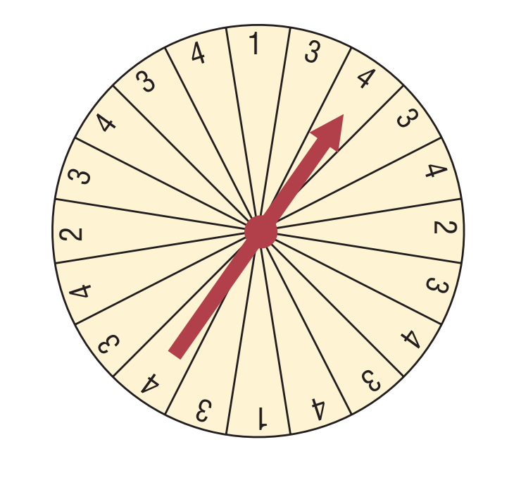

*a.* The customer wins $10.   
*b.* The customer wins money.   
*c.* The customer wins a coupon.

***Answer:***

1. 0.1 b. 0.2 c. 0.8

**BT 02. Rolling a Die** If a die is rolled one time, find these probabilities.

*a.* Getting a 2  
*b.* Getting a number greater than 6   
*c.* Getting an odd number  
*d.* Getting a 4 or an odd number  
*e.* Getting a number less than 7   
*f.* Getting a number greater than or equal to 3  
*g.* Getting a number greater than 2 and an even number

***Answer:***

1. 1/6 b. 0 c. 1/2 d. 2/3 e. 1 f. 2/3 g. 1/3

**BT 03. Rolling Two Dice.** If two dice are rolled one time, find the probability of getting these results.

*a.* A sum of 9  
*b.* A sum of 7 or 11  
*c.* Doubles  
*d.* A sum less than 9  
*e.* A sum greater than or equal to 10.

***Answer:***

1. 1/9 b. 2/9 c. 1/6 d. 13/18 e. 1/6

**BT 04. Prime Numbers** A prime number is a number that is evenly divisible only by 1 and itself. The prime numbers less than 100 are listed below.

2 3 5 7 11 13 17 19 23 29 31  
37 41 43 47 53 59 61 67 71 73 79  
83 89 97

Choose one of these numbers at random. Find the probability that

1. The number is even
2. The sum of the number’s digits is even
3. The number is greater than 50

***Answer:***

1. 0.04 b. 0.52 c. 0.4

**BT 05. Computers in Elementary Schools** Elementary and secondary schools were classified by the number of computers they had. Choose one of these schools at random.

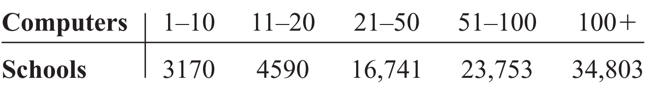

Choose one school at random. Find the probability that it has

*a.* 50 or fewer computers   
*b.* More than 100 computers   
*c.* No more than 20 computers

***Answer:***

1. 0.295 b. 0.419 c. 0.093
2. **The ADDITION RULES for PROBABILITY**

**BT 06.** Determine whether these events are mutually exclusive.

a. Roll a die: Get an even number, and get a number less than 3.   
b. Roll a die: Get a prime number (2, 3, 5), and get an odd number.   
c. Roll a die: Get a number greater than 3, and get a number less than 3.   
d. Select a student in your class: The student has blond hair, and the student has blue eyes.   
e. Select a student in your college: The student is a sophomore, and the student is a business major.   
f. Select any course: It is a calculus course, and it is an English course.   
g. Select a registered voter: The voter is a Republican, and the voter is a Democrat.

***Answer:***

1. No b. No c. Yes d. No e. No f. Yes g. Yes

**BT 07**. **Selecting a Fish** In a fish tank, there are 24 goldfish, 2 angel fish, and 5 guppies. If a fish is selected at random, find the probability that it is a goldfish or an angel fish.

***Answer:***  26/31

**BT 08**. **Young Adult Residences** According to the Bureau of the Census, the following statistics describe the number (in thousands) of young adults living at home or in a dormitory in the year 2004.

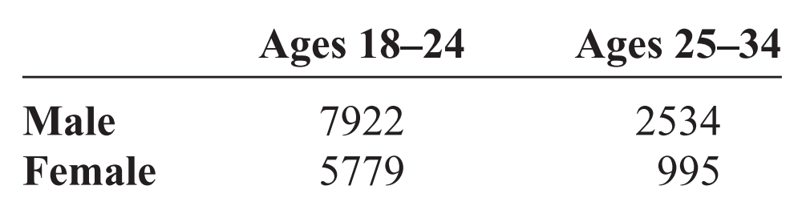

Choose one student at random. Find the probability that the student is

*a.* A female student aged 25–34   
*b.* Male or aged 18–24   
*c.* Under 25 years of age and not male

***Answer:***

1. 0.058 b. 0.942 c. 0.335

**BT 09.** **Endangered Species** The chart below shows the numbers of endangered and threatened species both here in the United States and abroad.

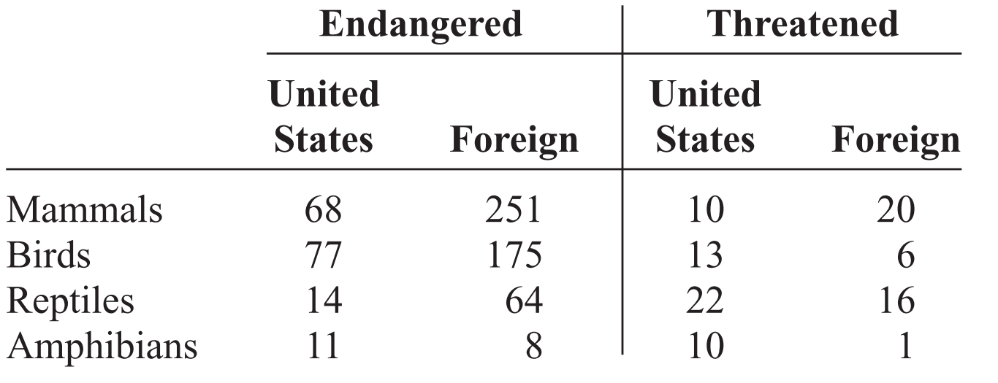

Choose one species at random. Find the probability that it is

1. Threatened and in the United States
2. An endangered foreign bird
3. A mammal or a threatened foreign species

***Answer:***

1. 0.072 b. 0.229 c. 0.4856

**BT 10**. **Door-to-Door Sales** A sales representative who visits customers at home finds she sells 0, 1, 2, 3, or 4 items according to the following frequency distribution.

**Items sold Frequency**0 8  
1 10  
2 3  
3 2  
4 1

Find the probability that she sells the following.

*a.* Exactly 1 item  
*b.* More than 2 items  
*c.* At least 1 item  
*d.* At most 3 items

***Answer:***

1. 5/12 b. 1/8 c. 2/3 d. 23/24

**BT 11**. **Selecting a Card** If one card is drawn from an ordinary deck of cards, find the probability of getting  
the following.

*a.* A king or a queen or a jack  
*b.* A club or a heart or a spade  
*c.* A king or a queen or a diamond  
*d.* An ace or a diamond or a heart  
*e.* A 9 or a 10 or a spade or a club.

***Answer:***

1. 3/13 b. 3/4 c. 19/52 d. 7/13 e. 15/26

**BT 12**. **Rolling Die** Two dice are rolled. Find the probability of getting

*a.* A sum of 8, 9, or 10  
*b.* Doubles or a sum of 7  
*c.* A sum greater than 9 or less than 4  
*d.* Based on the answers to *a*, *b*, and *c*, which is least  
likely to occur?

***Answer:***

1. 1/3 b. 1/3 c. 1/4 d. *Choice c is least likely to occur*